Q-1 (1) Create a simple LAN using Packet Tracer and connect multiple PCs using a switch.

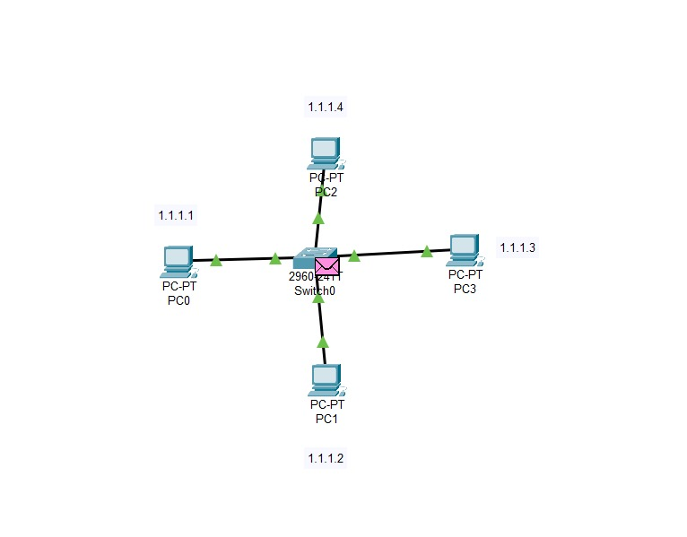

Q-1 (2) Assign static IP addresses to devices in a LAN and verify connectivity using the ping command.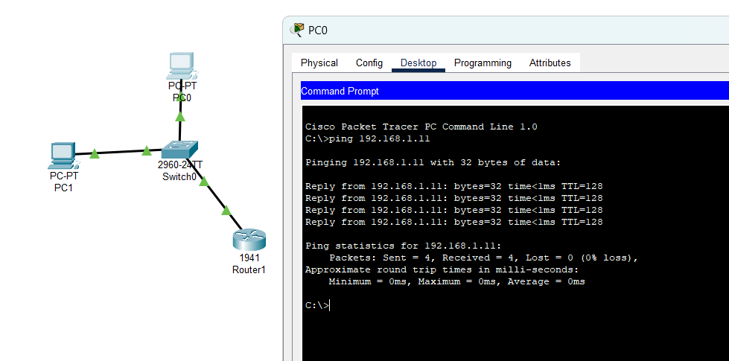

Q-1 (3) Configure and test a DHCP server to assign IP addresses dynamically.

